

A Report on

Challenges of

**Virtual Reality**

Under Guidance OF

Shubhasri Roy

Submitted by **Ranajit Roy** (A-47)

CSE 2nd Year

Roll No: 10400116133

Registration No: 161040110114



CERTIFICATE OF APPROVAL

This is to certify that Ranajit Roy, a student of B.tech 2nd year, Computer Science and Engineering of Institute of Engineering and Management, Kolkata (W.B.) has submitted his project work entitled “Challenges of **Virtual Reality**” under my guidance during the fourth semester of the session 2018. The above referred project work is complete and up to the standard both in respect of its content and literary.

I hereby forward the project.

Forwarded:

______________________________

(Shubhasri Roy)

IEM, Kolkata(WB)

_____________________________

**(Prof. (Dr.)** Dr. Debika Bhattacharyya**)**

**HOD of Computer Science and Engineering**

**IEM, Kolkata(WB)**

Acknowledgement

I am indebted to the faculty of IEM, Saltlake, who have encouraged me and supported me in completing this report. I am pleased to acknowledge the helpful comments and suggestions provided by friends.

For their continuous inspiration, I am also thankful to my parents for their moral support and inspired me to complete this task. I am presenting the report which is designed to be utilized as a compact study tool on Virtual Reality and some ideas to work on. Thanks to all again who supported me.

**-Ranajit Roy**

Summary

**Virtual reality** (**VR**) is a computer-generated scenario that simulates a realistic experience. The immersive environment can be similar to the real world in order to create a lifelike experience grounded in realityor sci-fi. **Virtual reality** is an artificial environment that is created with software and presented to the user in such a way that the user suspends belief and accepts it as a real environment. On a computer, **virtual reality** is primarily experienced through two of the five senses: sight and sound.

**Virtual Reality (VR)**, sometimes called Virtual Environments (VE) has drawn much attention in the last few years. Extensive media coverage has caused this interest to grow rapidly. Very few people, however, really know what VR actually is, what its basic principles and its associated problems are. In this technical report a historical overview of virtual reality has been presented, basic terminology and classes of VR systems are listed along with applications of this technology in science, work, and entertainment areas. An insightful study of typical VR systems is done. All components of VR application and interrelations between them are thoroughly examined including the basic required input devices and 3D input devices. Additionally, human factors and their implication on the design issues of VE are discussed. Finally, the future of VR has been considered in two aspects: technological and social. New research directions, technological frontiers and potential applications are pointed out. The possible positive and negative influence of VR on life of average people is speculated with the help of a survey and future possibilities are identified. The challenges associated with it are also highlighted and specific possible measures have also been mentioned.

Table of Contents

**Topic Page No.**

Introduction 6

Methodology 7

History 8

Concept of Virtual Reality 10

VR Technology 13

Challenges of VR 14

Conclusion & Analysis 18

Recommendations 19

References 20

Appendix 21

Introduction

Nowadays computer graphics is used in many domains of our life. Towards the end of the 20th century it is becoming difficult to imagine an architect, engineer, or interior designer working without a graphics workstation. So basically in the last years the stormy development of microprocessor technology has brought faster and faster computers to the market. These machines are equipped with better and faster graphics boards and their prices fall down rapidly. It becomes possible even for an average user, to move into the world of computer graphics. This fascination with a new reality often starts with the exciting computer games and lasts forever. It allows us to see the surrounding world in other dimension and to experience things that are not accessible in real life or even not yet created. Moreover, the world of three-dimensional graphics has neither borders nor constraints and can be created and manipulated by ourselves as we wish – we can enhance it by a fourth dimension: the dimension of our imagination.

But this is actually not enough: people always want more. They want to step into this world and interact with it – instead of just watching a picture on the monitor. So this technology which becomes overwhelmingly popular and fashionable in current decade is called Virtual Reality (VR). The very first essence of VR was presented by Ivan Sutherland in 1965: “make that (virtual) world in the window look real, sound real, feel real, and respond realistically to the viewer’s actions”. It has been a long time since then, yet a lot of research has been done and status quo: “the Sutherland’s challenge of the Promised Land has not been reached yet but we are at least in sight of it”.

Sutherland’s challenge, which can be briefly described as offering presence simulation to users as an interface metaphor to a synthesized world, has become the research agenda for a growing community of researchers and industries. The motivation for such a research direction is twofold. From an evolutionary perspective, virtual reality is seen as a way to overcome limitations of standard human-computer interfaces; from a revolutionary perspective, virtual reality technology opens the door to new types of applications that exploit the possibilities offered by presence simulation.

Though the ideal challenge is to ensure that the screen is a window through which one sees a virtual world. The challenge is to make sure that world look real, act real, sound real, feel real.

Methodology

**Methodology** can the systematic, theoretical analysis of the methods applied to a field of study. It comprises the theoretical analysis of the body of methods and principles associated with a branch of knowledge.

In this technical report we have focused on the origin of VR, we have had a short glimpse on the past projects. We have quoted scientists who gave presentations on such origins and worked on their discoveries to reach the present day. The first research has been focused on the motivation and definitely the application of Virtual Reality. The immersion levels of the VE system has been taken into account and properly highlighted.

It has been followed by a deep projection of VR technologies of modern era. After completion of such technical aspects, we have decided to move in the equipment and other instrumental devices preferably the input devices. We have held a brief discussion on “3D input devices”. Then we have focused on the challenges associated with such an upcoming intellectual excellence. Among the challenges, the Technological and Cultural barriers have been highlighted. Based on the entire technical report, we have developed an analysis and managed to draw out an important conclusion.

History

Focussing on the last three decades of research in virtual reality and its highlights:

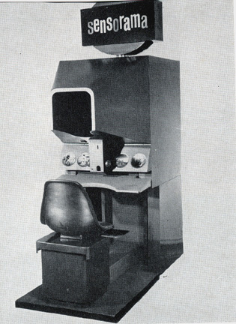

• **Sensorama** – in years 1960-1962 Morton Heilig created a multi-sensory simulator. A pre-recorded film in colour and stereo, was augmented by binaural sound, scent, wind and vibration experiences. This was the first approach to create a virtual reality system and it had all the features of such an environment, but it was not interactive.

• **The Ultimate Display** – in 1965 Ivan Sutherland proposed the ultimate solution of virtual reality: an artificial world construction concept that included interactive graphics, force-feedback, sound, smell and taste.

• “**The Sword of Damocles**” – the first virtual reality system realized in hardware, not in concept. Ivan Sutherland constructs a device considered as the first Head Mounted Display (HMD), with appropriate head tracking. It supported a stereo view that was updated correctly according to the user’s head position and orientation.

**Fig 1: Sensorama**

• **GROPE** – the first prototype of a force-feedback system realized at the University of North Carolina (UNC) in 1971.

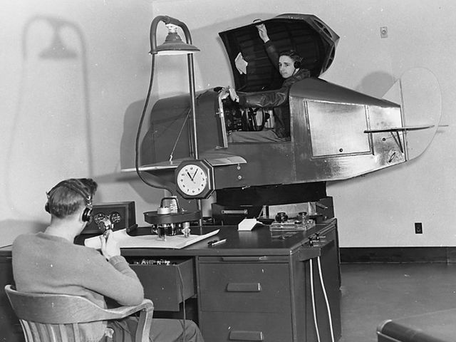• **VIDEOPLACE** – Artificial Reality created in 1975 by Myron Krueger – “a conceptual environment, with no existence”. In this system the silhouettes of the users grabbed by the cameras were projected on a large screen. The participants were able to interact one with the other thanks to the image processing techniques that determined their positions in 2D screen’s space.

• **VCASS** – Thomas Furness at the US Air Force’s Armstrong Medical Research Laboratories developed in 1982 the Visually Coupled Airborne Systems Simulator – an advanced flight simulator. The fighter pilot wore a HMD that augmented the out-the window view by the graphics describing targeting or optimal flight path information.

**Fig 2: VCASS**

• **VIVED** – Virtual Visual Environment Display – constructed at the NASA Ames in 1984 with off-the-shelf technology a stereoscopic monochrome HMD.

• **VPL** – the VPL company manufactures the popular DataGlove (1985) and the Eyephone HMD (1988) – the first commercially available VR devices.

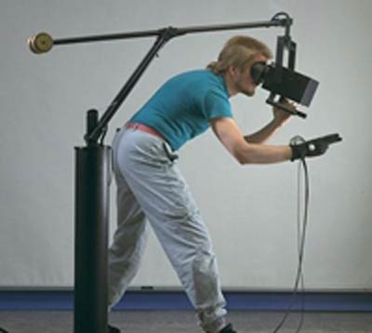

• **BOOM** – commercialized in 1989 by the Fake Space Labs. BOOM is a small box containing two CRT monitors that can be viewed through the eye holes. The user can grab the box, keep it by the eyes and move through the virtual world, as the mechanical arm measures the position and orientation of the box.

• **UNC Walkthrough** project – in the second half of 1980s at the University of North Carolina an architectural walkthrough application was developed. Several VR devices were constructed to improve the quality of this system like: HMDs, optical trackers and the Pixel-Plane graphics engine.

**Figure 3: BOOM VR**

• **Virtual Wind Tunnel** – developed in early 1990s at the NASA Ames application that allowed the observation and investigation of flow-fields with the help of BOOM and DataGlove (see also section 1.3.2).

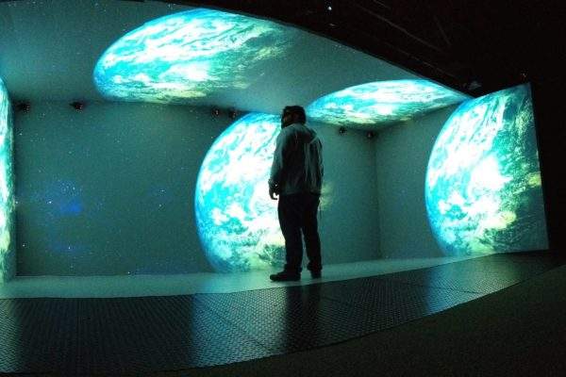• **CAVE** – presented in 1992 CAVE (CAVE Automatic Virtual Environment) is a virtual reality and scientific visualization system. Instead of using a HMD it projects stereoscopic images on the walls of room (user must wear LCD shutter glasses). This approach assures superior quality and resolution of viewed images, and wider field of view in comparison to HMD based systems.

**Fig 4: CAVE VR**

Concept of Virtual Reality

The terminologies Virtual Reality (VR) and Virtual Environments (VE) are the terms that are the most popular and most often used are used in computer community interchangeably, though there are many other. The others are Synthetic Experience, Virtual Worlds, Artificial Worlds or Artificial Reality. All these names mean the same though so we present some authorized definitions–

* “Real-time interactive graphics with three-dimensional models, combined with a display technology that gives the user the immersion in the model world and direct manipulation.”
* “The illusion of participation in a synthetic environment rather than external observation of such an environment. VR relies on a three-dimensional, stereoscopic head-tracker displays, hand/body tracking and binaural sound. VR is an immersive, multi-sensory experience.”
* “Computer simulations that use 3D graphics and devices such as the DataGlove to allow the user to interact with the simulation.”
* “Virtual reality refers to immersive, interactive, multi-sensory, viewer-cantered, three dimensional computer generated environments and the combination of technologies required to build these environments.”
* “Virtual reality lets you navigate and view a world of three dimensions in real time, with six degrees of freedom. In essence, virtual reality is clone of physical reality.”

All these definitions are essentially equivalent. They all mean that VR is an interactive and immersive experience in a simulated world of its own – and this measure we will use to determine the level of advance of VR systems.

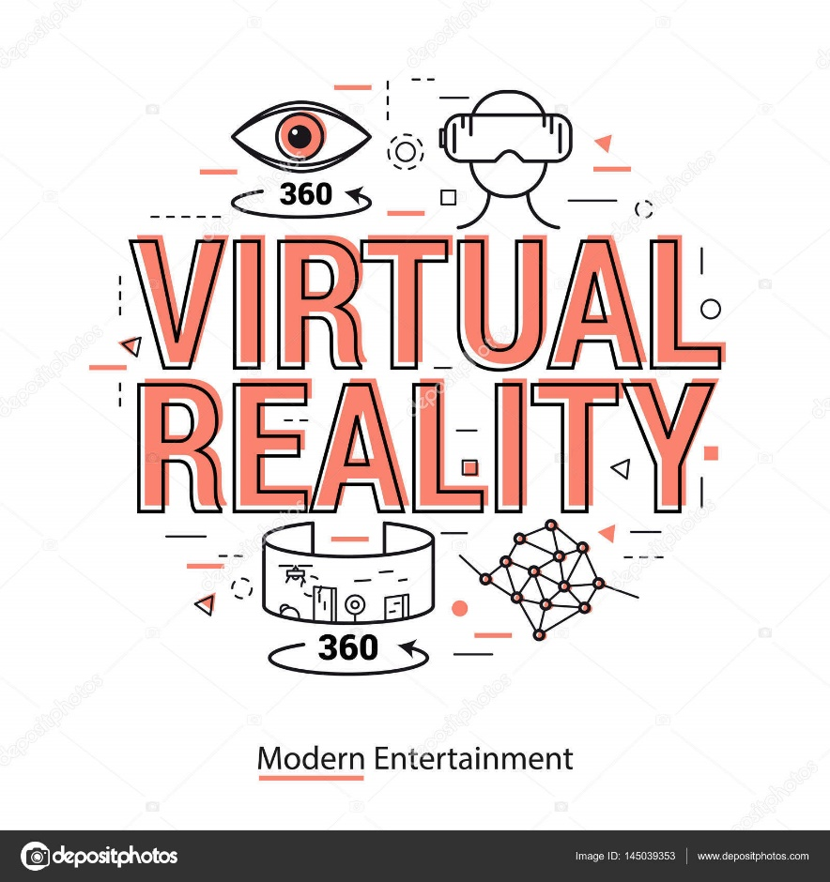

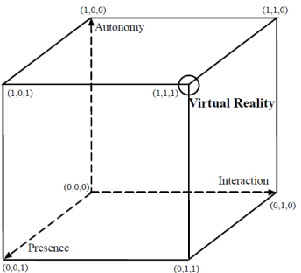

**Fig 5: Autonomy, interaction, presence in VR – Zeitzer’s cube**

Many people, mainly the researchers use the term Virtual Environments instead of Virtual Reality “because of the hype and the associated unrealistic expectations”. Moreover, there are two important terms that must be mentioned when talking about VR: Telepresence and Cyberspace. They are both tightly coupled with VR, but have a slightly different context:

Another higher level technology is Augmented Reality (AR) Many people, mainly the researchers use the term Virtual Environments instead of Virtual Reality “because of the hype and the associated unrealistic expectations”. Moreover, there are two important terms that must be mentioned when talking about VR: Telepresence and Cyberspace. They are both tightly coupled with VR, but have a slightly different context:

* **Telepresence** – is a specific kind of virtual reality that simulates a real but remote (in terms of distance or scale) environment. Another more precise definition says that telepresence occurs when “at the work site, the manipulators have the dexterity to allow the operator to perform normal human functions; at the control station, the operator receives sufficient quantity and quality of sensory feedback to provide a feeling of actual presence at the worksite”
* **Cyberspace** – was invented and defined by William Gibson as “a consensual hallucination experienced daily by billions of legitimate operators a graphics representation of data abstracted from the banks of every computer in human system”. Today the term Cyberspace is rather associated with entertainment systems and World Wide Web (Internet).

**Levels of Immersions in VR:** In a virtual environment system, a computer generates certain sensory impressions that are delivered directly to the human senses. So the type and the quality of these impressions determine the level of immersion and the feeling of presence in VR. Ideally the high-resolution, high-quality and consistent over all the displays, information should be presented to all of the user’s senses. Moreover, the environment itself should react realistically to the user’s actions. The practice, however, is very different from this ideal case. Many applications stimulate only one or a few of the senses, very often with low-quality and unsynchronized information. We can group the VR systems accordingly to the level of immersion they offer to the user:

* **Immersive systems –** this is the ultimate version of VR systems. It lets the user totally immerse in computer generated world with the help of HMD that supports a stereoscopic view of the scene accordingly to the user’s position and orientation. Such systems may be enhanced by audio, haptic and sensory interfaces.
* **Desktop VR –** sometimes called Window on World (WoW) systems. This is the simplest type of virtual reality applications. It uses a conventional monitor to display the image usually mono-scopic of the world. Any other sensory output is not supported.
* **Fish Tank VR –** improved version of Desktop VR. These systems support head tracking and therefore improve the feeling of “of being there” thanks to the motion parallax effect. They still use a conventional monitor but generally do not support sensory output.

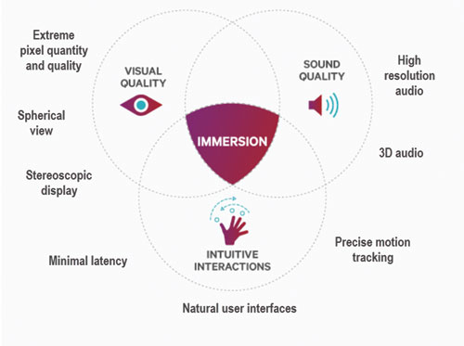

**Fig 6: Immersion in VR**

VR Technology

**Hardware**

* **Personal Computer (PC)/Console/Smartphone:**Computers are used to process inputs and outputs sequentially. To power the content creation and production significant computing power is required, thereby making PC/consoles/smartphones important part of VR systems. The VR content is what users view inside and perceive so it is equally important as other hardware.
* 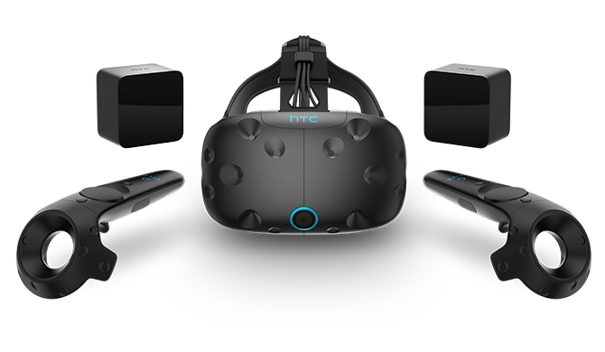**Input Devices:**Input devices provides users the sense of immersion and determines the way a user communicates with the computer. It helps users to navigate and interact within a VR environment to make it intuitive and natural as possible. Unfortunately, the current state of technology is not advanced enough to support this yet. Most commonly used input devices are joysticks, force Balls/Tracking balls, controller wands, data gloves, trackpads, On-device control buttons, motion trackers, bodysuits, treadmills and motion platforms (virtual omni).
* **Output Devices:**  
  Input devices provides users the sense of immersion and determines the way a user communicates with the computer. It helps users to navigate and interact within a VR environment to make it intuitive and natural as possible. Unfortunately, the current state of technology is not advanced enough to support this yet. Most commonly used input devices are joysticks, cyber gloves, force Balls/Tracking balls, controller wands, data gloves, trackpads, On-device control buttons, motion trackers, bodysuits, treadmills and motion platforms (virtual omni).

**Fig 7: VR input & output devices**

**Software**

Apart from input, output hardware and its coordination, the underlying software is also equally important. It is responsible for the managing of I/O devices, analysing incoming data and generating proper feedback. The whole application is time-critical and software must manage it: input data must be handled timely and the system response that is sent to the output displays must be prompt in order not to destroy the feeling of immersion. The developer can start with basic software development kit (SDK) from a VR headset vendor and build their own VWG from scratch. SDK usually provide the basic drivers, an interface to access tracking data and call graphical rendering libraries. There are some ready-made VWG for particular VR experiences and has options to add high-level scripts.

Challenges of VR

Virtual reality can lead to state of the art technologies like second life [13-14]. In fact, virtual reality program Second Life poses new challenges to its more than millions of users that include economic interactions, methods of communication and documentation. In other words, Second Life is a MUVE, or Multi-user Virtual Environment. Growth rate of using VR technology in the world is illustrated in the graph given below.

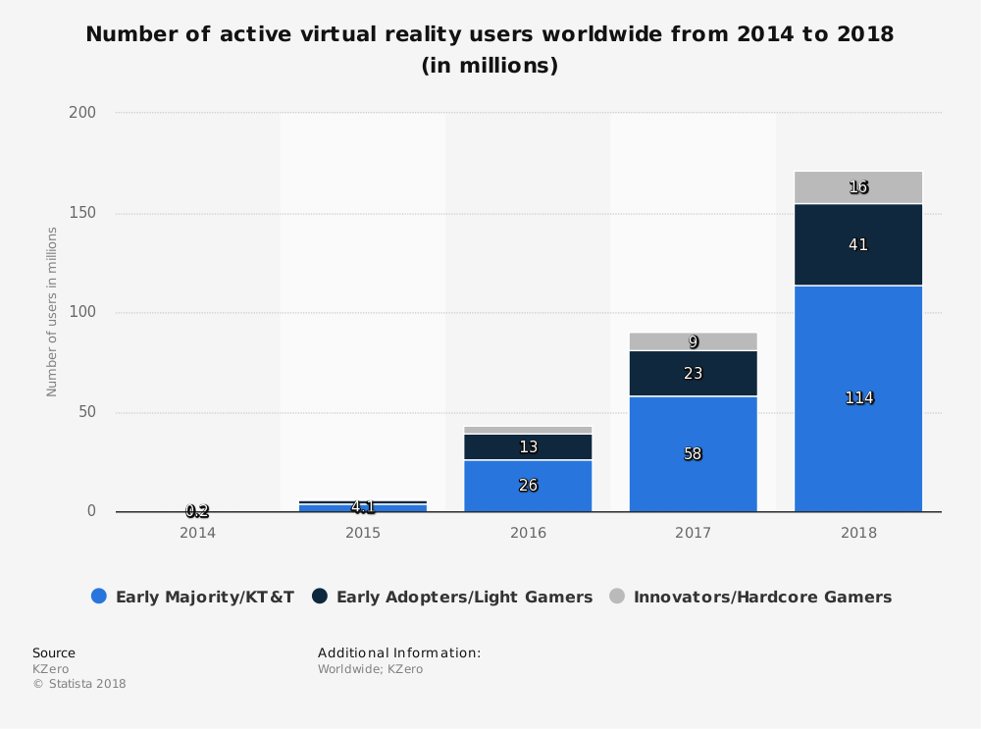

**Fig 8: Growth rate of VR users around the world**

**Second Life** is an online virtual world developed by an American company named Linden Lab. It was launched on June 23, 2003. A number of free client programs, or Viewers, enable Second Life users, called Residents, to interact with each other through avatars. Residents can explore the world (known as the grid), meet other residents, socialize, participate in individual and group activities, and create and trade virtual property and services with one another. In the other hand, Second Life comprises the viewer (also known as the client) executing on the user's personal computer, and several thousand servers operated by Linden Lab. Second Life is intended for people aged 16 and over. Now that worlds like Second Life have a stable and growing user base, various organizations and businesses are beginning to colonize, build and grow in these worlds. Built into the software is a three-dimensional modelling tool based on simple geometric shapes that allows residents to build virtual objects. There is also a procedural scripting language, Linden Scripting Language, which can be used to add interactivity to objects. Sculpted prims (sculpties), mesh, textures for clothing or other objects, animations, and gestures can be created using external software and imported. Like many advantageous technologies, beside opportunities of Virtual Reality and Second Life, unavoidable challenges appear, too. In fact, using Virtual Reality and Second Life offers both technical and cultural challenges. We can describe these challenges in two following sections.

1. **Technical Challenges:**Second Life in Virtual Reality environments functions by streaming all data to the user live over the Internet with minimal local caching of frequently used data. The user is expected to have a minimum of 300kbit/s of Internet bandwidth for basic functionality, with 1Mbit/s providing better performance. Due to the proprietary communications protocols, it is not possible to use a network proxy/caching service to reduce network load when many people are all using the same location, such as when used for group activities in a school or business. These are some problems:
   1. 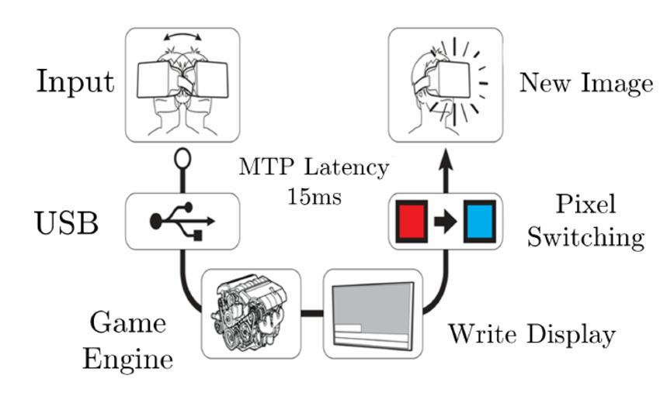**Latency:** Latency in drawing new content is the biggest technical challenge AR (Augmented Reality) and VR face today, and has been since the inception of these ideas. Any system is bound to have a threshold latency which comes from the frame rate of the content being drawn, the refresh rate of the display, and the input lag from the interaction that started the new content draw. The question of what the human eye perceives as “fluid motion” is a very complex one, but VR headsets typically target a latency less than 30-40 ms. Problems originating from latency are not isolated to the VR field. All systems that have the same interface of interaction between a human and the corresponding content draw on a screen face the same issue. VR and AR are no longer limited to the entertainment industry only. There is an immense potential in delivering services remotely using VR Doctors around the world are experimenting with these technologies to deliver their services remotely. In order for such novel applications to be successful, latency issues must be solved.

**Figure 9: Latency Issue**

* 1. **Spherical Sound Design:** AR and VR have the unique problem of requiring spherical sound design by default. One challenge to solve in 2018 is of making the appropriate tools that can handle such sound design. While spatial sound design is nothing new, VR requires at least 6 degrees of freedom to work as expected - that means that perceived audio has to come from the conventional 3 directions (x, y, z), as well as the diagonals between them to give the impression that the sound is attached to the object that generates it. Another challenge is to make sure that the user does not get overwhelmed by sensory overload. The world of VR can be chaotic, and the human brain is not built to handle such chaos effectively. The sound designers are required to make sure that the sounds are culled appropriately. We 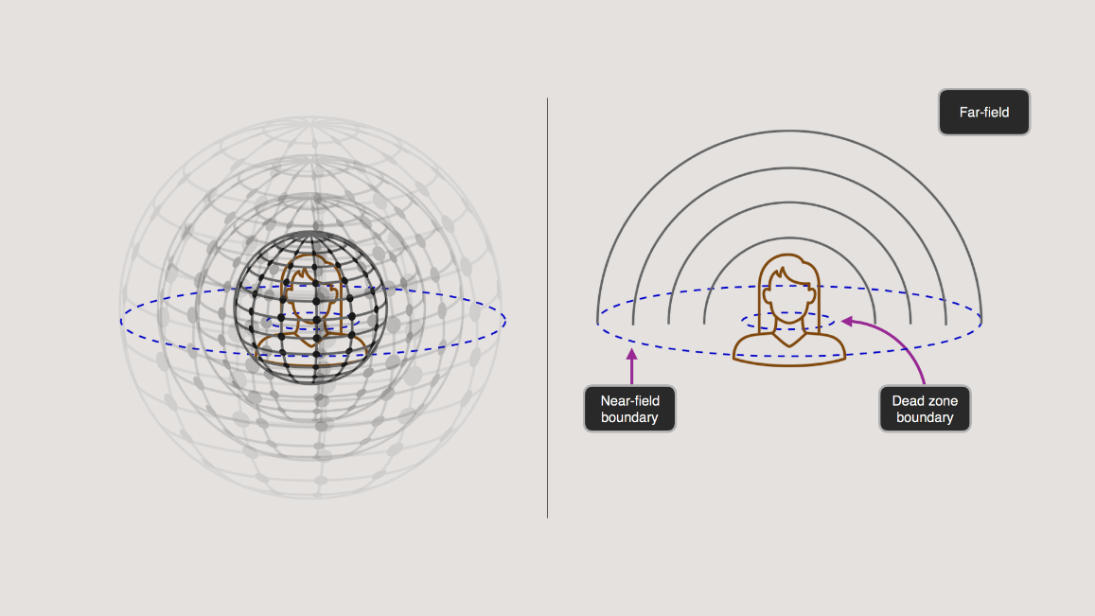need better tools for that in 2018.

**Fig 10: Spherical sound design**

Due to Virtual Reality’s and Second Life’s rapid growth rate, it has suffered from difficulties related to system instability. These include increased system latency, and intermittent client crashes. However, some faults are caused by the system's use of an "asset server" cluster, on which the actual data governing objects is stored separately from the areas of the world and the avatars that use those objects. The communication between the main servers and the asset cluster appears to constitute a bottleneck which frequently causes problems. Typically, when asset server downtime is announced, users are advised not to build, manipulate objects, or engage in business, leaving them with little to do but chat and generally reducing confidence in all businesses on the grid. Cost is another issue. In addition to appropriate internet band width and virtual reality environment and interfaces charges, establishing Second Life in virtual environments offers several membership plans, too. For example, for virtual learning, a premium account is required to purchase land, which is necessary to create a sustained and safe learning environment for students. However, increasingly powerful computer systems are becoming more affordable each year, but commercial VR systems that are sophisticated enough to offer complex models and diverse functionality are still expensive relative to personal computers.

1. **Collaboration:**Once you start being in a virtual world, you very quickly want to share the experience and not be alone. VR is particularly suited for collaborative work with people physically in the same space or in completely different parts of the world! When creating a collaborative application, you need to make sure each VR application is connected to one server, that all data between the applications are synchronized securely, that you can see the avatar of others.  
   You also need to pay a particular attention to the interactions: for example if one user is manipulating an object, you might want to prevent other users to manipulate the same object.
2. **Virtual World Creation:**We have seen that perceptive presence requires you to fool your senses in the most realistic way. Cognitive presence — fooling the mind, not the senses — results from a sense that your actions have effects on the virtual environment, and that these events are credible. This means that you must believe in the “rules” of the simulation. For this, you must make sure that your world is coherent, not necessarily realistic. If a player can grab a particular glass, for example, but can’t grab another one, it will break presence because the rules are not consistent. Once cognitive presence is broken, it’s very difficult to “fix” it. The player is constantly reminded that the simulation is not real, and it will take some time to accept it again as reality.
3. **Avatars:**When you are using a head-mounted display (HMD), you are completely immersed in the virtual world, and you don’t see your own body anymore. It is very important to display a virtual representation of yourself and others, called avatars. They can be realistic, look like yourself, or be completely different.  
   If your VR system offers full body tracking and if you want an avatar that has exactly the same dimensions as you, this can be a simple task. But if your VR system only has a few trackers and you want an avatar that is taller or smaller than you, it can be difficult to extrapolate the position of the limbs that are not tracked and to adapt your body posture to a different virtual body.
4. **High End Computers, VR Headsets & Related Costs:**There's no getting around it: full-fat VR headsets like the Oculus Rift (£598/$598), the HTC Vive (£759/$799) and the PlayStation VR (£349.99/$398) cost a lot of money. Even the cut-down mobile versions are expensive by the standards of smartphone accessories - £69/$79 for the Google Daydream View, for example, and £80/$99 for the latest Gear VR.  
   A huge cost is also should be invested upon the Computers used for VR as creating a high resolution images 30 times a second needs much computational power.

Conclusion & Analysis

Non-social and creative virtual worlds that potentially can be great tool for designers, are at the same time even bigger temptation for complete escape from reality. They offer to the user the possibility of modifying the surrounding according to one’s wishes (which is very often not possible in real world). Thanks to it, creating an artificial wonderland of dreams will be as easy as building a house using a Lego-set. With these considerations several existential questions arise: Is our everyday life so bad that so many people escape from it? Will VR make people at least happier? Which influence will it have on the ability of coexistence with other humans? This last question, becomes even more important when considering social virtual worlds, allowing people to communicate and collaborate. They can certainly be a great help in work and in everyday life, but are they going to replace physical contacts totally? Even today a lot of people spend hours on the telephone because they are too lazy to pay a visit to their friends. In virtual reality, the user will be able to create an image of himself/herself – often very idealized and far from reality. Hidden behind our masks we will meet only equally “perfect” but cold creatures.

It is common to have misconceptions on what VR can and cannot do, and to have negative reactions when noticing that VR “is not that real”. As for all technologies, but more importantly for a much emphasized and complex technology such as VR, it is important to choose appropriate applications with well define functionality objectives, to compare the abilities of VR with competing technologies for reaching those objectives, to ensure that the VR solution can be integrated with standard business practices, and to choose the right set of tools and techniques.

Nowadays, VR technology has been applied in several domains such as training simulators, medical and health care, education, scientific visualization, and entertainment industry. Virtual reality can lead to state of the art technologies too. VR is a term that applies both to computer-simulated environments that can simulate physical presence in places in the real world, as well as in imaginary worlds. Like many advantageous technologies, beside opportunities of Virtual Reality and Second Life, unavoidable challenges appear, too. In this technical report, Virtual reality types and structural elements of a virtual reality system are described. The correlation between Virtual Reality and Virtual Environment has been explained further. Then applications of virtual reality that providing us opportunities in various domains are described and at last, challenges of applying virtual reality technology are presented. Of course, efforts are underway to overcome the challenges in future to use the advantages of this technology as more as possible.

Recommendations

1. **Virtual reality could eventually impact all of the senses:**Breaking the barrier between the virtual world and the physical world with high-end touch sensors could be the next step in virtual reality, and it won't be here for a while, but VR hardware and software makers are already thinking about how this technology can go from immersive to fully interactive.
2. **It offers a new way of seeing our world:**VR is still in its early stages and it's still unclear how this platform will be used, and whether or not we'll like exactly how it turns out. Still We could watch someone you loved respond the way she used to, or eat cake a certain way. It is going to be interesting to see what happens when we aren't able to forget anything anymore.
3. **It will take a while for VR to gain traction:**VR is still in its very early stages, and it's likely that it will take many more years before it becomes mainstream. While there has been satisfactory statistics, it's still a clear indicator that VR and AR have a long way go before they become mainstream.
4. **Potential for Deep Behavioural Manipulation**Whether physical or virtual, human behaviour is situated and socially contextualized, and we are often unaware of the causal impact this fact has on learning mechanisms as well as on concurrent behaviour. It is plausible to assume that this will be true of novel media environments as well. Importantly, unlike other forms of media, VR can create a situation in which the user’s” entire *environment”* is determined by the creators of the virtual world, including “social hallucinations” induced by advanced avatar technology. Unlike physical environments, virtual environments can be modified quickly and easily with the goal of influencing behaviour.
5. **The Effects of Long-Term Immersion**First, and perhaps most obviously, we simply do not know the psychological impact of long-term immersion. So far, scientific research using VR has involved only brief periods of immersion, typically on the order of minutes rather than hours. Once the technology is adopted for personal use, there will be no limits on the time users choose to spend immersed. Similarly, most research using VR has been conducted using adult subjects. Once VR is available for commercial use, young adults and children will be able to immerse themselves in virtual environments. The risks that we discuss below are especially troublesome for these younger users who are not yet psychologically and neuro-physiologically fully developed.

References

1. G. Burdea and P. Coiffet, “Virtual Reality Technology”, John Wiley & Sons Inc, 1994.
2. I. Sutherland.”The Ultimate Display”, In Proc. Of the IFIP Congress, pp.506–508,1965.
3. M.W.Krueger, “Artifcial Reality”, Addison-WesleyPress,1983.
4. J.D.Foley, “Interfaces for Advanced Computing”, Scientifc American, vol.257, no.4, pp.126–135,1987.
5. J.Lanier, “TheDataGlove”, Scientifc American, vol.257, no.4, cover,1987.
6. G.Burdea and P.Coiffet, ”Virtual Reality Technology”, John Wiley and Son Inc., New York, USA, 1994
7. L. Liu, “Virtual reality applications in simulated course for tour guides”, IEEE Proc. Of 7th Int. Conf. on Computer Science & Education (ICCSE)**,** pp. 1672 – 1674, 2012.
8. A. Rizzo, P. Requejo, C. J. Winstein, B. Lange, G. Ragusa, A. Merians, J. Patton, P. Banerjee and M. Aisen, “Virtual Reality Applications for Addressing the Needs of those Aging with Disability”, Proc. of Workshop on Medicine Meets Virtual Reality(MMVR), pp. 510-516, 2011.
9. A. G. Abulrub, A. N.Attridge and M. A. Williams, “Virtual Reality in Engineering Education”, IEEE Global Engineering Education Conference (EDUCON), pp.751-757, 2011.
10. V. Kovalcík, J. Chmelík, M. Bezdeka and J. Sochor, “Virtual Reality System as a Tool for Education”, 20th International Conference on Computer Graphics, Visualization and Computer Vision, p. 15-18, 2012.

Appendix

**Workstation** [Page 6]:  
a desktop computer terminal, typically networked and more powerful than a personal computer.

**Augmented Reality** [Page 10]:  
a technology that superimposes a computer-generated image on a user's view of the real world, thus providing a composite view.

**Data glove** [Page 12]**:**It is an interactive device, resembling a gloveworn on the hand, which facilitates tactile sensing and fine-motion control in robotics and virtual reality. Data glovesare one of several types of electromechanical devices used in haptics applications.

**Cyber glove** [Page 12]**:**It is an input device for human–computer interaction worn like a glove. Various sensor technologies are used to capture physical data such as bending of fingers.

**Tracking** [Page 12]:  
It is used to expand or contract the amount of text on a page by expanding or reducing the amount of space between letters. It differs from kerning in that it is applied to an entire font or to a range of text, whereas kerning refers to certain letter pairs.

**Virtual Environment** [Page 13]:  
A computer that is running in a virtualmachine environment, which is the combination of virtualmachine monitor and hardware platform. For example, VMware running on an x86 computer is a virtual environment.

**Head-Mounted Display** [Page 14]:  
a display device, worn on the head or as part of a helmet, that has a small display optic in front of one (monocular HMD) or each eye (binocular HMD).